UNIT 4 MECHANISMS

1. Mechanism 1 – Nucleophilic Addition

Carbonyls with HCN and NaBH₄ (H⁻):

a)
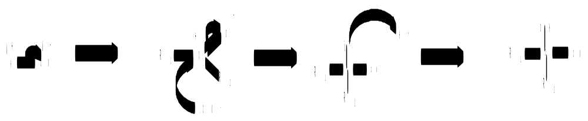
b)
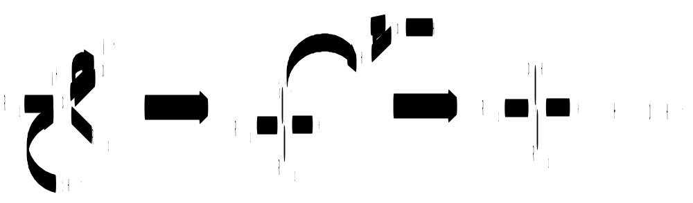

2. Mechanism 2 – Nucleophilic Addition-Elimination

Acyl chlorides with water, ammonia, alcohols and primary amines:

a)
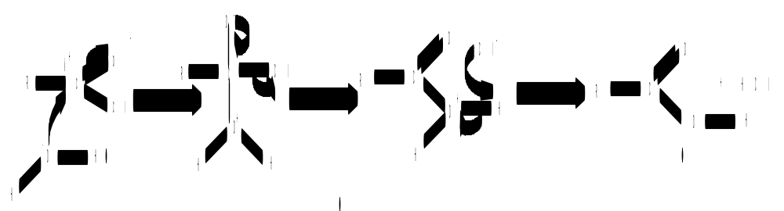

b)
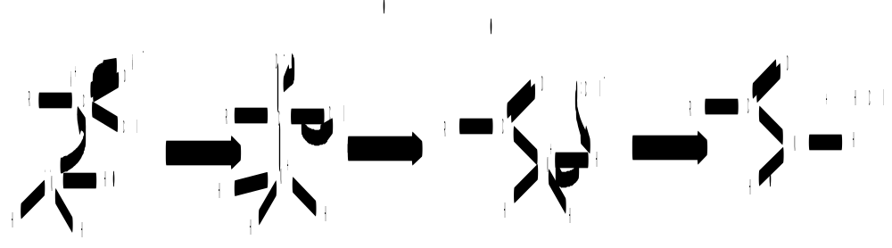

c)
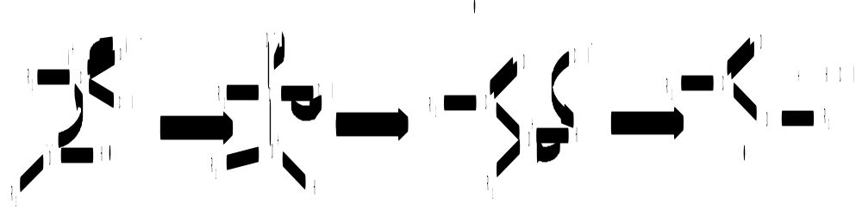

d)
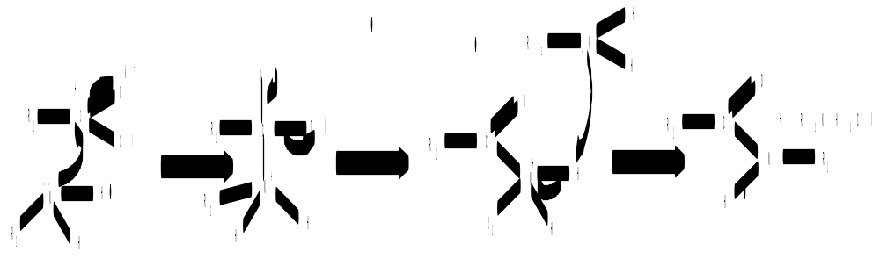

3. Mechanism 3 – Electrophilic Substitution

Nitration, alkylation and acylation of benzene rings:

a) H₂SO₄ + HNO₃ → H₂NO₃⁺ + HSO₄⁻
H₂NO₃⁺ → H₂O + NO₂⁺

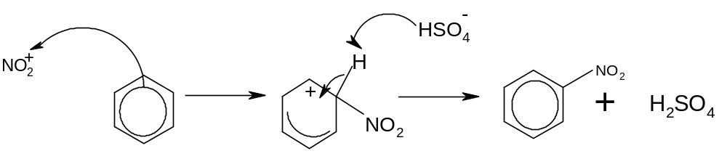
b) R-Cl + AlCl₃ → R⁺ + AlCl₄⁻ (using a haloalkane)
or
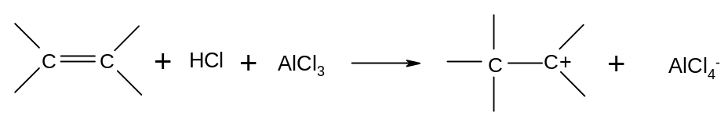
(using an alkene and HCl)

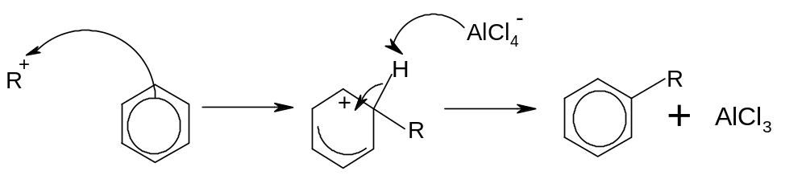

c) R-COCl + AlCl₃ → RCO⁺ + AlCl₄⁻

